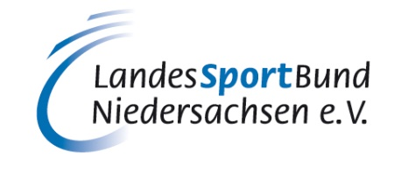
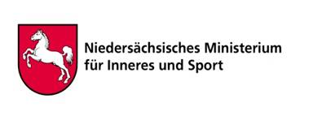

Joint Declaration in the Field of Sport Between
Ministry of Internal Affairs and Sport of Lower Saxony
- hereafter referred to as “Ministry” -

And
LandesSportBund Niedersachsen e.V. (State Sport Association of Lower Saxony)

- hereafter referred to as “LandesSportBund” –

And
The Department of Sport, Recreation, Arts and Culture of the Province of the Eastern Cape
- hereafter referred to as “DSRAC” -

INTRODUCTION:

Since the beginning of the partnership between the Eastern Cape and Lower Saxony, sport has been a major driver of the cooperation. Both, the people of the Eastern Cape and the people of Lower Saxony benefit in multiple ways from the collaboration in sports. The partnership underlines the importance of sport as a vehicle to connect people. The steady exchange of athletes and coaches, the volunteer program, the youth exchange and many more joint projects do not only lead to an exchange of knowledge in the sport area but also to a better international understanding in general. All parties wish to maintain and strengthen their relations in the field of sport and will therefore continue to make great efforts for a fruitful partnership. The following Declaration shall be based upon the Joint Declaration by the Government of the State of Lower Saxony, Federal Republic of Germany and the Government of the Eastern Cape Province, Republic of South Africa, signed in Hanover on October 15th 2015 and signed in Bhisho on October 20th 2015.

PURPOSE:

This Declaration is aimed at the advancement of sport development and promotes mutual relations in the field of sport.

PARTNERS TO THE DECLARATION:

The Declaration is concluded between the Ministry, the LandesSportBund and DSRAC.

IMPLEMENTATION PROTOCOL:

Program and project design, implementation, monitoring, evaluation and reporting will be done on a yearly basis. The basis for annual planning and review will be an Annual Plan of Operations.

Annual joint planning and review will take place in either of the two countries in alternate cycles.
The parties will act as equal partners and shall maintain open and reliable communication lines.

AREAS OF STRATEGIC FOCUS:

The following shall constitute the strategic focus of this Declaration:

- Organizational development
- Training and development measures
- Social cohesion
- Development-policy voluntary service in the field of sport
- Youth exchange

Each strategic focus area shall have Priority Action Fields as follows:

ORGANIZATIONAL DEVELOPMENT:

Priority Action Fields:

- Sports club development
- Capacity building for sport coordinating structures (sports councils)
- Federations support

TRAINING AND DEVELOPMENT MEASURES:

Priority Action Fields:

- Research on demographic and social trends
- Enhancement of academies of sport and sports schools
- Sports specific coaches and technical officials exchange program Youth leadership education
- Train the trainer program

SOCIAL COHESION:

Priority Action Fields:

- Sport awareness days and campaigns (sports badge)
- Inter-regional and international competitions and athletes exchange program

DEVELOPMENT-POLICY VOLUNTARY SERVICE IN THE FIELD OF SPORT

Priority Action Fields:

- Volunteer services (mobilization, recruitment, training, placement, support and recognition e.g. Sports graduates/unemployed youth)

YOUTH EXCHANGE:

Priority Action Fields

- Youth exchange program

ROLES OF THE RESPECTIVE PARTNERS:
ROLE OF THE MINISTRY:

- It is responsible for the political representation of sport towards the Lower Saxon government which funds organized sport in Lower Saxony
- It is partner of organized sport in Lower Saxony
- It commits itself to the support of international sport projects and comments on the sport projects according to the sports funding regulations of Lower Saxony
- lt identifies a representative responsible for the maintenance of the partnership in the Eastern Cape

ROLE OF LANDESSPORTBUND:

- lt represents all sport codes towards Lower Saxony Government
- lt facilitates and coordinates all projects conducted by Lower Saxony Federations and Clubs
- lt identifies a relevant officer responsible for the maintenance of the partnership

ROLE OF THE DSRAC

- lt represents all sport codes towards Eastern Cape Government
- lt facilitates and coordinates all projects conducted by the Eastern Cape Sports Federations and Clubs
- lt identifies a relevant officer responsible for the maintenance of the partnership

Signed at Hanover,

……………………………………………..  Minister Boris Pistorius (Ministry) | ……………………………………………..  MEC Majodina (DSRAC)
……………………………………………..  Prof. Dr. Wolf-Rüdiger Umbach (LandesSportBund) | ……………………………………………..  Norbert Engelhardt (LandesSportBund)

